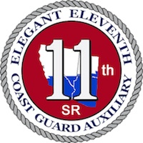

DISTRICT 11 South AWARDS PROGRAM

U. S. COAST GUARD AUXILIARY

Effective 1 January 2019

REV 1 December 2018

TABLE OF CONTENTS
Contents
Award Templates: 5
DISTRICT 11 SOUTH AWARDS PROGRAM 7
REFERENCE 7
ATTACHMENTS 7
1. INTRODUCTION 7
2. AWARDS PHILOSOPHY 7
3. PAST DIVISION COMMANDERS AWARDS COORDINATOR (PDCA-AC) 8
A. ORIGINATOR: 8
B. FLOTILLA COMMANDER (FC): 8
C. DIVISION COMMANDER (DCDR): 8
D. PAST DIVISION COMMANDERS ASSOCIATION AWARDS COORDINATOR (PDCA-AC): 8
E. PAST DIVISION COMMANDERS ASSOCIATION AWARDS COMMITTEE: 8
F. PAST DIVISION COMMANDERS ASSOCIATION AWARDS COORDINATOR (PDCA-AC): 8
G. DISTRICT COMMODORE (DCO): 9
H. APPROVING AUTHORITY (AA): 9
I DISTRICT COMMODORE (DCO): 9
4. AWARD CATEGORIES: 9
A. National Awards 9
B. External Awards 9
C. Formal Awards 9
D. Auxiliary Annual Service Performance Awards 9
E. District Awards 10
F. Informal Recognition 10
5. NATIONAL AWARDS 10
6. EXTERNAL AWARDS 10
7. FORMAL AWARDS: 11
A. Acronyms: 11
B. MERITORIOUS TEAM COMMENDATION (Active Duty Award) 11
C. AUXILIARY COMMANDANT’S LETTER OF COMMENDATION (Active Duty Award) 11
D. AUXILIARY ACHIEVEMENT MEDAL 11
E. AUXILIARY COMMENDATION MEDAL 11
F. AUXILIARY MEDAL OF OPERATIONAL MERIT 11
G. AUXILIARY MERITORIOUS SERVICE MEDAL 12
H. AUXILIARY PLAQUE OF 12
I. AUXILIARY LEGION OF MERIT 12
J. THE AUXILIARY DISTINGUISHED SERVICE MEDAL 12
8. SUMMARY OF ACTION OR SERVICE * 13
9. AWARDS APPROVAL PROCESS 14
A. Awards for District Bridge Members, District Staff Officers and Assistant District Staff Officer Awards 14
B. ACLOC and MTC 14
C. Higher awards 14
D. Active Duty Generated Awards for Auxiliarists 14
10. WRITING THE AWARD CITATION 15
11. SUBMISSION AND APPROVAL PROCESS –Templates 17
12. PROCESS FOR NON-APPROVED AWARDS 19
13. AWARDS PRESENTATION PROTOCOL 19
GENERAL AWARD PROCESS 20
ATTACHMENT - AWARD CHECKLISTS 21
Coast Guard Meritorious Team Commendation (Active Duty Award) 21
ACLOC – Auxiliary Commandant’s Letter of Commendation (Active Duty Award) 22
Auxiliary Achievement Medal 23
Auxiliary Commendation Medal 24
Auxiliary Medal of Operational Merit 25
Auxiliary Meritorious Service Medal 26
Auxiliary Plaque of Merit 27
Auxiliary Legion of Merit 28
Auxiliary Distinguished Service Medal 29
AWARDS PROCESS FLOW CHARTS 30
HIGHER LEVEL FORMAL AWARDS: 31
DISTRICT STAFF AWARDS 32
DCO Approves/Disapproves Award: 33
Awards by Due Dates 34
Jan 15 District 11S Auxiliarist of the Year (AUXOY): 34
Apr 1 NACO 3 Star Award for Diversity Excellence: 34
Apr 1 NACO Membership Growth Award – Individual: 34
Apr 1 NACO Membership Growth Award – Flotilla: 34
Apr 1 NACO Membership Growth Award – Division: 35
Apr 1 NACO Membership Growth Award – District: 35
Apr 1 NACO 3 Star Award for Excellence in Auxiliary Core Training (AUXCT) 35
May 1 Commodore Donald L. Frasch Inspirational Leadership Award: 35
Jun 1 District 11S Publications Award: 35
Aug 1 Auxiliary Diversity Award: 36
Oct 1 Charles S. Greanoff Award Inspirational Leadership Award 37
Nov 1 AFRAS Silver Award (Association for Rescue at Sea) 37
DEC 1 Auxiliarist of the Year (AUXOY) National 37
AUTOMATICALLY GENERATED AWARDS 38
Marine Retailers Association Award (MRAA) 38
Boat US Best Flotilla Award 38
Coast Guard RBS Award of Excellence (Eagle Award) 38
AUTOMATICALLY GENERATED AWARDS BY DISTRICT 11S 39
District Commodore’s Certificate of Excellence for: 39
• Recreational Boating Safety 39
• Operations/Marine Safety 39
• Member Services 39
• Multi-Department 39
• Operational Standby 39
• Radio Watch Standing, Coast Guard Operational & Administrative Support 39
• Aviation 39
• Commodore William Mansfield Perpetual Trophy- 39
• Commodore’s Cup Awards 39
PRESIDENTS VOLUNTEER SERVICE AWARD 40
AWARDS TEMPLATES 41
Description of USCG Auxiliary Awards: 52

Award Templates:
Figure 1: Citation - Meritorious Team Commendation 42
Figure 2: Citation - Auxiliary Commandant Letter of Commendation 43
Figure 3: Citation - The Auxiliary Achievement Medal 44
Figure 4: Citation - The Auxiliary Commendation Medal 45
Figure 5: Citation - The Auxiliary Medal Of Operational Merit 46
Figure 6: Citation - The Auxiliary Meritorious Service Medal 47
Figure 7: Citation - The Auxiliary Plaque Of Merit 48
Figure 8: Citation - The Coast Guard Auxiliary Legion Of Merit 49
Figure 9: Citation - The Auxiliary Distinguished Service Medal 50
Figure 10: USCG Auxiliary D11S Revised 1650 51

DISTRICT 11 SOUTH AWARDS PROGRAM
REFERENCE: (a) Chapter 11, Auxiliary Manual, COMDTINST M16790.1G
(b) Medals and Awards Manual, COMDTINST M1650.25D (series)
(c) U. S. Coast Guard Auxiliary Awards Primer, CG-BSX-1 dated 22 FEB 2016
(d) District 11S Standing Rules Annex A, Award Procedures and Policies
(e) Coast Guard Awards and Recognition Handbook, COMDTPUB P1650.37
(f) Awards Templates

ATTACHMENTS: Composite List of Available Awards
Awards Process Flow Charts
District 11 South Award Approval Process Check Lists
Awards by Submission Due Dates to District Commodore

1. INTRODUCTION - This document is intended to clarify and define the District 11 South awards program for Auxiliarists. Awards are generated by Auxiliarists and intended to be approved through the Auxiliary Chain of Leadership to the District Commodore for final review and approval of the award.

This process does not apply to awards generated by the Active Duty Coast Guard for Auxiliary performance and support. The process for those awards is governed by the appropriate Station, Sector, District or Commandant Instruction and are reviewed by the AUXLO and forwarded to the Director of Auxiliary.

2. AWARDS PHILOSOPHY - Our Awards Program is designed to acknowledge extraordinary achievements of extraordinary members, those who extended themselves beyond expectation in contributing their skills, talents, and experiences to a mission, project, and/or program of the Coast Guard and/or Auxiliary.

Our aim with the Awards Program is to make Auxiliary members feel appreciated and recognized for their work, collectively and individually, for the awards to be relevant and appropriate for the results recorded. District Eleven South awards strive to reinforce for Auxiliarists the feeling that they are an integrated partner of the Coast Guard Team and are making a difference in the maritime missions that are our purpose. Awards should acknowledge and reflect the significant impact and results of Auxiliary contributions to the general public as well as to our Coast Guard and recreational boating safety customers.

Lastly, we believe our awards should motivate and re-commit Auxiliarists to continuing, enthusiastic volunteer service at the highest level of performance.

3. PAST DIVISION COMMANDERS AWARDS COORDINATOR (PDCA-AC) Effective with the implementation of this program, a Past Division Commanders Association Awards Coordinator (PDCA-AC) will be appointed by the President of the Past Division Commanders Association (P-PDCA). Upon appointment, the PDCA-AC will recruit, train and coordinate the PDCA Awards Committee in reviewing awards. The PDCA-AC will be responsible for tracking the processing and data entry of all Auxiliarist awards.

- ORIGINATOR: All nominations for Auxiliary awards will begin with the Originator of the awards request. The Originator is responsible for ensuring the appropriate award is requested for the action that took place. He/she is also responsible for writing and preparing Coast Guard Award Recommendation (CG-1650), in compliance with the standards in this document. The Originator of the CG-1650 is responsible for properly and completely completing the Citation to Accompany the CG-1650. Upon proper completion of the documents referenced above, the Originator signs the CG-1650 and forwards the entire package to the Flotilla Commander.

- FLOTILLA COMMANDER (FC): The FC reviews the CG-1650 and the accompanying Citation for appropriateness, format and completeness. If the request is inappropriate, not in the proper format, or is incomplete, the FC returns the package to the Originator for correction. If everything is in order the FC signs the CG-1650 and forwards the entire package to the Division Commander (DCDR) for further review.

- DIVISION COMMANDER (DCDR): The DCDR reviews the CG-1650 and the accompanying Citation for appropriateness, format and completeness. If the request is inappropriate, not in the proper format or is incomplete, the DCDR sends the request back down the Chain of Leadership to the Originator for correction. If everything is in order the DCDR signs the CG-1650 and forwards the entire package to the Past Division Commanders Association Awards Coordinator (PDCA-AC) for logging and forwarding.

- PAST DIVISION COMMANDERS ASSOCIATION AWARDS COORDINATOR (PDCA-AC): The PDCA-AC reviews the CG-1650 and the accompanying Citation for appropriateness, format and completeness. If the request is inappropriate, not in the proper format or is incomplete, the PDCA-AC sends the request back down the Chain of Leadership to the Originator for correction. If everything is in order the PDCA-AC assigns the package a tracking number, using the format (YY-NO) and forwards the entire package to the Past Division Commanders Awards Committee members for review.

- PAST DIVISION COMMANDERS ASSOCIATION AWARDS COMMITTEE: The members of the PDCA Awards Committee evaluate the request and recommend individually whether to approve or disapprove the request. If the recommendation is to disapprove the request, the PDCA Awards Committee member will state the reason on the PDCA Awards Approval / Disapproval Form then return the PDCA APPROVAL / DISAPPROVAL RECOMMENDATION FORM to the PDCA-AC.

F. PAST DIVISION COMMANDERS ASSOCIATION AWARDS COORDINATOR (PDCA-AC): The PDCA-AC tabulates the approval / disapproval recommendations. In the event of a tied number of recommendations the PDCA-AC breaks the tie by adding his/her vote to the total. The PDCA-AC will then sign a PDCA Approval / Disapproval Form recommending either that the award be approved or disapproved based on the PDCA Awards Committee’s recommendation, and forward the package, including only the number of PDCA Awards Committee recommendations, to the District Commodore (DCO). At this point the PDCA-AC will acknowledge the receipt of and processing of the Awards request in a formal letter to the Originator, with copies to the DCDR and FC.

G. DISTRICT COMMODORE (DCO): The DCO evaluates the award request, taking into account the recommendations of the PDCA Awards Committee and the standards set forth in this document and recommends either approval or disapproval of the request, signs the CG-1650, and forwards the package to the Approving Authority, either the Sector Commander (through the AUXLO) in the case of Operational Awards; or the DIRAUX, in the case of Administrative Awards.

H. APPROVING AUTHORITY (AA): The AA evaluates the award request, considering all the recommendations and makes a final decision as to whether the award should be granted. The Approving Authority’s decision is final and there is no appeal. The AA signs the CG-1650 and returns the package to the DCO.

I DISTRICT COMMODORE (DCO): The DCO returns the package to the PDCA-AC who notifies the Originator via a formal letter with copies to the DCDR and the FC. If the award is approved, it is then up to the DCDR, FC, and Originator to make the presentation of the award in an appropriate way. If the award is not approved, the PDCA-AC will explain the reasons for denying the award in a formal letter to the Originator, with copies to the DCDR and FC.

4. AWARD CATEGORIES:

A. National Awards – Available to individual division and flotillas for specific accomplishments.

B. External Awards - Awards for which Auxiliarists are eligible from organizations outside of the Auxiliary such as safe boating associations, rescue at sea and boating retail organizations.

C. Formal Awards - These awards are reserved for Auxiliarists who distinguish themselves in Auxiliary service. There are different levels depending on whether the accomplishment is operational or administrative. These rewards are recognized by the presentation of ribbons.

D. Auxiliary Annual Service Performance Awards – These awards recognize the individual contribution of Auxiliarists in Recruiting, Vessel Examinations (VE), Recreational Boating Safety Visitation Program (RBSVP), Public Education (PE), and the Operations Program (OPS).

E. District Awards – District Awards are given in various categories determined by the District Bridge and Board, to recognize Auxiliarists who have contributed significant hours in these areas. The source documents for these awards is AUXDATA and the compilations and tabulations are done by DIRAUX staff. These awards do not go through the Auxiliary awards process.

F. Informal Recognition - Informal recognition is used to recognize individuals, groups, or teams for achieving specific goals or completing special projects. It is flexible and can be adapted to the needs and preferences of individuals, groups, and teams. Informal recognition is used as a means of expressing appreciation for a specific effort. It doesn’t require a lengthy justification or high-level approval. Informal recognition may be accompanied by a nonmonetary recognition item.

5. NATIONAL AWARDS
I. Auxiliary Diversity Award
II. NACO 3-Star Award for Diversity Excellence
III. Commodore Charles S. Greanoff Inspirational Leadership Award
IV. Auxiliarist of the Year Award
V. NACO Membership Growth Award - District
VI. NACO Membership Growth Award - Division
VII. NACO Membership Growth Award –Flotilla
VIII. NACO Membership Growth Award – Individual
IX. Coast Guard RBS Award of Excellence (Eagle Award)

6. EXTERNAL AWARDS
I. Association for Rescue at Sea
II. Marine Retailers Association Award
III. National Boating Federation Award
IV. BoatUS Award

7. FORMAL AWARDS:

A. Acronyms:
I. MTC - Meritorious Team Commendation
II. ACLOC - Auxiliary Commandant’s Letter of Commendation
III. AAM - Auxiliary Achievement Medal
IV. ACM - Auxiliary Commendation Medal
V. AMOM - Auxiliary Medal of Operational Merit
VI. AMSM - Auxiliary Meritorious Service Medal
VII. APOM - Auxiliary Plaque of Merit
VIII. ALOM -Auxiliary Legion of Merit
IX. ADSM - Auxiliary Distinguished Service Medal
X. SOA - Summary of Action

B. MERITORIOUS TEAM COMMENDATION (Active Duty Award) – This award is an Active Duty Award, and as such it is initiated by an Active Duty Command and does not go through the Auxiliary Awards process. To be eligible, an Auxiliarist must have made a significant contribution to the group or team cited for the award. Only those Auxiliarists who serve for the entire meritorious period and make a significant contribution to the overall team accomplishments should be included.
C. AUXILIARY COMMANDANT’S LETTER OF COMMENDATION (Active Duty Award) – This award is an Active Duty Award, and as such it is initiated by an Active Duty Command and does not go through the Auxiliary Awards process. The award is intended for Auxiliarists serving in any capacity with the Coast Guard or Auxiliary for a superior act(s) of service resulting in unusual and/or outstanding achievement, whose performance is lesser than that required for the Auxiliary Achievement Medal. The award can also be used to recognize an Auxiliarist’s service/performance for a special event or project.
D. AUXILIARY ACHIEVEMENT MEDAL - This award recognizes outstanding achievement or service of a nature which is worthy of special recognition as described below. The Auxiliary Achievement Medal is for recognition of Auxiliarists who have maintained an outstanding level of performance and/or achievement over a period to further authorized activities of the Auxiliary. The achievements could be in administration or operations.
E. AUXILIARY COMMENDATION MEDAL - The Auxiliary Commendation Medal is for outstanding administrative services. This requires services accomplished in a manner, which is much better than could normally be expected from an Auxiliarist of like capability and experience. Neither doing a difficult job well nor doing a routine job in an excellent manner will suffice. The achievement must be truly outstanding.
F. AUXILIARY MEDAL OF OPERATIONAL MERIT - This award recognizes outstanding achievement or service of an operational nature (defined as direct, hands on, underway, surface or airborne aviation mission activity) worthy of special recognition. To receive the Medal of Operational Merit, only skill is required not extreme skill. Therefore, it does not have to be a risk to the Auxiliarist’s life. Outstanding operational performance and other meritorious operational service have been included in this category. This was added to allow recognition of a cumulative series of operational services, none of which, standing alone, would merit this award, but taken as a group, do merit this level of recognition.
G. AUXILIARY MERITORIOUS SERVICE MEDAL - The meritorious performance of duty must have enhanced Auxiliary goals. This performance must clearly be of a nature much higher than that normally expected, and which has a significant positive effect on the ability of the Coast Guard and/or the Auxiliary to complete its missions and goals.
H. AUXILIARY PLAQUE OF MERIT - This award recognizes heroism in the face of grave personal risk and which clearly stands out as above normal expectations. The key aspects of performance for award of the Auxiliary Plaque of Merit are extreme skill, assist or rescue, and risk to the Auxiliarist’s life. The Auxiliary Plaque of Merit can be given for an assist or rescue only. The Auxiliarist must have exercised extreme skill, as opposed to just skill required for the Medal of Operational Merit. Lastly, there must have been risk to the Auxiliarist’s life. Neither the assist nor rescue needs be successful, only that the action required extreme skill and was performed or attempted at risk to the Auxiliarist’s life.
I. AUXILIARY LEGION OF MERIT - The Auxiliary Legion of Merit is awarded for service comparable to the ADSM but in a duty of lesser, though considerable, responsibility. This is awarded only by the Commandant.
J. THE AUXILIARY DISTINGUISHED SERVICE MEDAL - The Auxiliary Distinguished Service Medal recognizes Auxiliarists who distinguish themselves by contributing exceptionally meritorious and distinguished service to the Coast Guard Auxiliary. The ADSM is awarded only by the Commandant.

8. SUMMARY OF ACTION OR SERVICE * - To make the recommendation for Auxiliary Meritorious Service Medal, Auxiliary Plaque of Merit, Auxiliary Legion of Merit, or the Auxiliary Distinguished Service Medal, a Summary of Action or service (SOA) (except as in the asterisk note) must be prepared by the recommending Auxiliary elected or appointed leader. This must be attached to the award recommendation, along with any documents (newspaper clippings, statements from those assisted, copies of Coast Guard station logs, letters, etc.) that help justify the recommendation. This summary is the most important part of the recommendation. Approval or disapproval will be based on the justification presented. Avoid generalities and excessive use of superlatives. Include any of the following, if pertinent or available:

A. Specific examples
B. Service impact
C. Positive results
D. Monetary savings
E. Eyewitness statements
F. Nature of action
G. Date or inclusive dates
H. Precise location
I. Time of day
J. Names of all involved
K. Detailed weather conditions
L. Amount of natural or artificial light
M. Any other pertinent information

* The Summary of Action is not required for the AMOM, ACM, the AAM, or the ACLOC.
The Summary of Action for the AMSM should be limited to one page.

9. AWARDS APPROVAL PROCESS - Detailed processing instructions for the various awards are contained in References (a) through (e). Attachment (3) specifies the due dates for submission, approval and the criteria for each award. The approval chain for the various awards is as follows.

A. Awards for District Bridge Members, District Staff Officers and Assistant District Staff Officer Awards - Originator District Staff Officer District Directorate Chief District Chief of Staff District Commodore Director Auxiliary with a copy sent to the District Awards Coordinator.

B. ACLOC and MTC – These awards are Active Duty Awards and are initiated by Active Duty Commands and do not go through the Auxiliary Awards process. See GENERAL AWARD PROCESS below.

C. Higher awards - Originator Flotilla Commander Division Commander Past Division Commanders Association Awards Coordinator Past Division Commanders Association Awards Committee Past Division Commanders Association Awards Coordinator District Commodore Sector Auxiliary Liaison Officer or DIRAUX.

D. Active Duty Generated Awards for Auxiliarists – Active Duty Commands will forward approved awards to the Auxiliary Liaison Officer Director of the Auxiliary. DIRAUX will forward a copy of the approved award to the District Commodore, the District Chief of Staff and the Past Division Commanders Association Awards Coordinator for logging and tracking.

10. WRITING THE AWARD CITATION - As explained in Reference (e) the award citation should be carefully prepared, be concise, and be easily read aloud. It should read and flow well enough so that someone who knows nothing about the Coast Guard could read the award or listen to it being read and understand it in its entirety. It should be straightforward and avoid superfluous text, cover only the primary action(s) for which the award is intended, be factual, and contain no classified information.

Some general formatting guidelines for all citations include:
A. All citations shall consist of one brief paragraph consisting of three parts; the opening sentence, the statement of heroic acts or meritorious achievement, and the commentary remarks.
B. All awards must be in 12-point, Times New Roman bold font and the text must be justified.
C. The ACLOC award must be justified and have a top margin of 1.9 inches, bottom margin of 1.0 inches, left and right margins are to be 1.0 inches and line count is must be a minimum of 12 lines. This is an Active Duty Award, and as such it is initiated by Active Duty Commands and does not go through the Auxiliary Awards process.
D. MTC award must be justified and have a top margin of 1.9 inches, bottom margin of 1.0 inches, left and right margins are to be 1.25 inches and line count is must be a minimum of 12 lines. This is an Active Duty Award, and as such it is initiated by Active Duty Commands and does not go through the Auxiliary Awards process.
E. All formal awards AAM. ACM, AMOM, AMSM, must be justified and have a top margin of 0.7 inches, left, and right margins 0f 1.0 inches and bottom margin of 1.25 inches. They must be no longer than 12 lines. Enough space must be left for the bottom margin to allow the placement of the 2-5/16 in gold seal on the bottom, left side of the citation.
F. Citations for ALOM and ADSM must be justified and have a top margin of 0.7 inches, left, and right margins 0f 1.0 inches and bottom margin of 1.25 inches. They must be at least 12 lines long but no longer than 16 lines in length. Enough space must be left for the bottom margin to allow the placement of the 2-5/16 in gold seal on the bottom, left side of the citation.
G. If you are not experienced in writing awards for members, get help from your FC or DCDR to ensure successful award citations.

H. Award of Operational Merit, Auxiliary Meritorious Service Award, Plaque of Merit and Auxiliary Distinguished Service Award all require supporting documentation (SOA). All others require only the CG1650 form and the well-written and properly formatted citation.
I. When you recommend a member(s) for an award, do not indicate to the member that he/she/they are to receive an award until you are certain that the award has been approved by the Sector or DIRAUX.
J. The Past Commanders Association Awards Coordinator may contact you to ask that the citation be re-worked in order to secure approval, or to advise you why an award was not approved.
K. The ACLOC and MTC are the only awards written in portrait format.
L. Numbers nine and below are to be spelled out and numbers 10 and above are to be numerical.
M. Unless an Auxiliarist holds or has held the title of District Commodore or higher, they must be referred to as either “Mr.” or “Ms.” throughout the text of the citation. If they hold or have held the title of District Commodore or higher, then they must be referred to as “Commodore.”
N. Acronyms other than those for the member's office may be used in the citation with the acronym immediately following in parenthesis. (i.e. Aids to Navigation)
O. The CG-1650 must be filled out. Some common omissions are:
- The period being recognized is left blank (block #2)
  - A listing of all previous award earned during period being recognized (NO copy required) (block #10)
  - The date the award will be presented should be completed. (block #9A)
  - To sign electronically, use /S/ and type your full name
P. Generally, the higher-level awards require a greater degree of action by the member, resulting in a bigger impact on the local area/organization/country/world
Q. It shall be the responsibility of each member in the process to ensure that the award meets the criteria required for each award. They shall check the spelling, grammar, line count for each award, correct type and point, correct margins, etc. prior to forwarding up the Chain of Leadership. R. If the award is found to be deficient or incorrect in any of these aspects, it should be returned to the last person approving the award for correction and/or clarification.

11. SUBMISSION AND APPROVAL PROCESS –Templates for the ACLOC, MTC, AAM, ACM, ADSM, ALOM, AMOM, and AMSM are available on the USCG Auxiliary District 11S Website at the following address:
URL - TBD.
A. The primary focus for awards should be how to effectively recognize the member. This may entail some re-working of the citation and/or Summary of Action or service at any step in the approval process.
B. Unlike active duty and reserve awards, Auxiliary awards do not get processed and reviewed by an awards board. This is beneficial in terms of time, logistics, and expenses that are avoided. Nevertheless, Auxiliary awards, particularly those presented in national forums, undergo a detailed edit and review process from their start at the hands of the award originator, to the actual presentation.
C. The following comprises the detailed process for writing and submitting member awards.
I. All awards must be submitted to the Sector Commander or the DIRAUX NO LATER THAN 60 DAYS PRIOR TO THE PRESENTATION DATE. Most sectors require a minimum of 60 days to process all awards. You need to allow for the award going up the Chain of Leadership to ensure that the DCO has time to submit the award to the Sector or DIRAUX at least 60 days prior to the presentation date.
II. All award citations and Form CG-1650 must be in WORD format.
III. The member should be nominated at the appropriate level. Most Auxiliary awards can be recommended by any member.
IV. A Summary of Action or service (SOA) must be prepared for the applicable awards (See Section 8 above.)
V. The CG-1650 Form along with the appropriate Award Check List (Attachment 1) must be filled out and signed by the award originator. These forms must be submitted along with the award citation. (Form CG-1650) can be obtained at: http://forms.cgaux.org/forms1.php) Your signature on this form indicates:
a. You have completed the appropriate Award Checklist
b. You have completed the CG-1650 properly

c. All requirements for the award have been met
d. The award format is correct
e. The correct template has been used
f. The award has been proofed for:
i. Margins
ii. Font type and size
iii. Punctuation
iv. Grammar
v. Quantifiable and verifiable data has been used and citation content justifies the level of the award.
vi. All members are responsible for maintaining a log of all awards that they have processed including a copy of the citation, the CG 1650 and the checklist. If a Meritorious Team Award, a copy of the participants should also be maintained.

D. The Flotilla Commander’s review will be done utilizing the included Awards Checklist along with References (a) through (g). If the award meets all criteria for content, format and award criteria the FC signs the attached Form CG 1650 and Awards Checklist in word using /S/ and typing their name. If the award does not meet the requirements for the award the FC may make the corrections or may return the package to the originator to make the necessary changes/modifications. The completed package is then forwarded to the DCDR.
E. The Division Commander’s review will be done utilizing the included Awards Checklist along with References (a) through (g). If the award meets all criteria for content, format and award criteria, the DCDR signs the Form CG 1650 along with the Award Checklist.
F, If the award is an Auxiliary Commandant’s Letter of Commendation or a Meritorious Team Commendation, the Award Package would then be forwarded directly to the Sector Commander (through the AUXLO) or the DIRAUX.
G. All other award nominations are forwarded to the Past Division Commanders Award Coordinator for processing.
H. Awards for DSOs and ADSOs are forwarded to the DDC, the DCOS and the DCO.
I. The CG-1650 is signed and the Award Package is forwarded to the DCO along with the checklist. Upon approval by the District Commodore the award is then forwarded to the Sector Commander (through the AUXLO) or the DIRAUX for approval and processing. After APPROVAL OR DISAPPROVAL, the entire package is sent to the District Commodore who returns it to the Past Division Commanders Association Awards Coordinator. The PDCA-AC will ensure that the Originator is notified by formal letter with copies to the DCDR and the FC.

12. PROCESS FOR NON-APPROVED AWARDS - If an award is not approved by the Approving Authority (AA), the award is sent back through the Chain of Leadership stating the reason for denial and recommendations as to whether a re-work of the award might be acceptable. The most typical reason that an award is not approved is due to the observation that the member was “just doing their job” and there was nothing more that was accomplished than should be reasonably expected of someone is a similar position.
A. If an award is not approved and the Flotilla Commander and/or Division Commander feels that some special recognition is warranted for the member(s), a certificate of appreciation or a nominal gift may be presented. The objective is to see that a deserving member ultimately receives appropriate recognition.
B. Each year awards training session will be conducted for all members in a leadership role and for interested members. This training will be done for national/external awards and for formal/district awards.

13. AWARDS PRESENTATION PROTOCOL - The purpose of the award presentation is to publicly demonstrate the importance of the award to recognize the individual member. The ceremony provides an opportunity for the Auxiliary Leadership and Active Duty Command members to know who earned the award and how the award was earned. The award ceremony should be simple, yet dignified.

A. Units shall prepare for the presentation of an award by assembling the membership and inviting the recipient’s family members and others as appropriate.
B. At the ceremony, the award recipient(s) may be called forward or “front and center”. He/she will come forward, stand at attention.
C. Those in attendance will be requested to stand and those in uniform should come to attention while the award is read.
D. After receiving the award, the recipient(s) shall return to their position.
E. Units shall make every attempt to take photos of the awards ceremony.
F. If possible, the family members of the award recipient should be notified to enable them to attend the presentation.

GENERAL AWARD PROCESS
These checklists are a tool for members involved in the awards process. Please use these to ensure that all awards are correct and complete. See section 8 of the D11S Awards Program document for the detailed submission process. All signatures must be in WORD format by using the /S/ and typing their name. All forms must be in WORD format. NO PDF or scanned copies.

- Originating member completes signs electronically and submits CG-1650 Form block 18 and the appropriate Award Checklist.

- Endorsing member signs electronically the CG-1650 Form block 19 and the included Award Checklist.

- Citation text is written in Times New Roman, 12-point bold font, justified margins.

- The citation meets the level of achievement as defined in References (a) and (b).

- Numbers 1- 9 spelled out in the citation (e.g. one man, 12 aircraft).

- Use of abbreviations is limited, and used only after the term is completely written out.

- Nominees’ name (last name written in all caps) and position properly formatted/spelled throughout the citation.

- Previous awards (block #10), if any, are indicated on the citation. (e.g., Gold Star in Lieu of a Second).

- Use the standard “opening” and “closing” sentences as provided on the award template for each different award.

- Minimum/maximum number of lines for awards, including standard opening/closing sentences.

  - ACLOC and MTC Awards: Maximum of 1 page, minimum of 12 lines (portrait).
  - AAM, ACM and AMSM: 12 lines maximum (landscape).
  - AMOM, ADM and LOM: 16 lines maximum (landscape).

- If action is operational in nature, include “O” device in commendation. “O” device criteria met as per references (a) and (b).

- You must have verifiable, quantitative data stating: what, how and results.

ATTACHMENT - AWARD CHECKLISTS

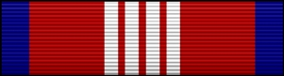

Coast Guard Meritorious Team Commendation (Active Duty Award)
DATE: ___________
ORIGINATOR: _________________________________________
MEMBERS’ NAMES: ___________________ ____________________
___________________ ____________________
___________________ ____________________
___________________ ____________________
(Use Second Page If Necessary)
- Awarded for OUTSTANDING and MERITORIOUS SERVICE to Auxiliarists in any team or group who are worthy of special recognition…fulfillment of Auxiliary goals at any organizational level (Flotilla, Division, District).

- State significant, positive effect on ability of the CG/AUX to exceed missions and goals.

- Justify in commendation as to why action is “above and beyond”.

- Submit this form along with completed and signed CG-1650 form and award citation.

- Use additional sheet of paper with names and member ID numbers and Flotilla number if there is not enough room on the CG-1650. (In addition to this form and attached to the CG-1650)

- Ensure all spelling, grammar, punctuation, line count, font type and size, and margins are correct.

- Check the award citation to ensure that it meets the criteria required?

Routing Signatures:
District Commodore ______________________ Recommended: _____ Not Recommended: ______
Active Duty Commander _____________________ Approved _____ Not Approved: ______
DIRAUX ______________________ Approved _____ Not Approved: ______

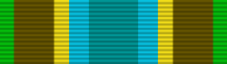

ACLOC – Auxiliary Commandant’s Letter of Commendation (Active Duty Award)
DATE: ___________
ORIGINATOR: ______________________________________
MEMBER’S NAME: ______________________________________
- Commendable action less than for Auxiliary Achievement Award (see below).

- Award being used to recognize a special event, new program and/or exceptional service

- Use the words EXCEPTIONAL in commendation.

- Justify in commendation why action is “above and beyond”.

- Ask yourself is member just “doing his/her job”? Is it worthy of an award? If worthy of an award, write the commendation to show why they are worthy.

- If action is operational in nature, include “O” device in commendation.

- No additional documentation attachments required.

- Submit this form along with completed and signed CG-1650 form and award citation.

- Are all: spelling, grammar, punctuation, line count, type and point, and margins correct?

- Does the award citation meet the criteria required?

Routing Signatures:
District Commodore ______________________ Recommended: _____ Not Recommended: ______
Active Duty Commander _____________________ Approved _____ Not Approved: ______
DIRAUX ______________________ Approved _____ Not Approved: ______

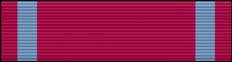

Auxiliary Achievement Medal
DATE: ___________
ORIGINATOR: ______________________________________
MEMBER’S NAME: ______________________________________
- Recognizes sustained professional leadership and/or management in either administration or operations.

- Service must be of an exceptional nature or an outstanding service that is worthy of special recognition.

- Citation states specifically that service is sustained for a period of one year or longer.

- SUSTAINED leadership over a period of ____ years.
- MERITORIOUS OPERATIONAL ACTIVITY for the citation period.
- MERITORIOUS ADMINISTRATIVE PERFORMANCE for the citation period.

- If action is operational in nature – include “O” device in commendation.

- Submit this form along with completed and signed CG-1650 form and award citation.

- Are all: spelling, grammar, punctuation, line count, type and point, and margins correct?
- Does the award citation meet the criteria required?

Routing Signatures:
Flotilla Commander ______________________ Recommended: _____ Not Recommended: ______
Division Commander ______________________ Recommended: _____ Not Recommended: ______
PDCA-AC ______________________ Recommended: _____ Not Recommended: ______
District Commodore ____ _________________ Recommended: _____ Not Recommended: ______
DIRAUX _____________________ Approved: _____ Not Approved: ______

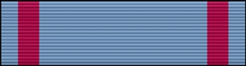

Auxiliary Commendation Medal
DATE: ___________
ORIGINATOR: ______________________________________
MEMBER’S NAME: _____________________________________
- Award is administrative in nature only…not appropriate for any operational activity.

- Recognizes truly outstanding administrative or service activity that furthers any authorized program area.

- Must be approved by a CG Commanding Officer O-6 or above.

- Wording in the commendation must demonstrate that the activity is TRULY OUTSTANDING.

  - Neither performing a difficult job well nor doing a routine job in an excellent manner qualifies for this award.

- Submit this form along with completed and signed CG 1650 form and award citation.

- Are all: spelling, grammar, punctuation, line count, type and point, and margins correct?

- Does the award citation meet the criteria required?

Routing Signatures:
Flotilla Commander ______________________ Recommended: _____ Not Recommended: ______
Division Commander ______________________ Recommended: _____ Not Recommended: ______
PDCA-AC ______________________ Recommended: _____ Not Recommended: ______
District Commodore ______________________ Recommended: _____ Not Recommended: ______
DIRAUX ______________________ Approved: _____ Not Approved: ______
Sector Commander: ____________________ Approved: _____ Not Approved: ______

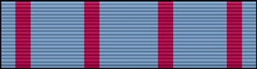

Auxiliary Medal of Operational Merit
DATE: ___________
ORIGINATOR: ______________________________________
MEMBER’S NAME: ______________________________________
- Equivalent to the US Coast Guard Commendation Medal with “O” device.

- Recognizes meritorious operational performance in assist, rescue or other operational service.

  - Issued ONLY for underway operations – aircraft, boat or ship.
  - SKILL required but not extreme skill.
  - There does not have to be a risk to the member’s life.

- Wording in commendation should include OUTSTANDING OPERATIONAL PERFORMANCE or SKILL in performing an ASSIST or RESCUE or OTHER OPERATIONAL MERITORIOUS SERVICE.

- Must be approved by a CG Commanding Officer O-6 or above.

- Submit this form along with completed and signed CG-1650 form and award citation.

- Are all: spelling, grammar, punctuation, line count, type and point, and margins correct?

- Does the award citation meet the criteria required?

Routing Signatures:
Flotilla Commander ______________________ Recommended: _____ Not Recommended: ______
Division Commander ______________________ Recommended: _____ Not Recommended: ______
PDCA-AC ______________________ Recommended: _____ Not Recommended: ______
District Commodore ______________________ Recommended: _____ Not Recommended: ______
DIRAUX ______________________ Approved: _____ Not Approved: ______
Sector Commander: ____________________ Approved: _____ Not Approved: ______

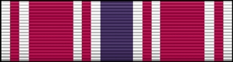

Auxiliary Meritorious Service Medal
DATE: ___________
ORIGINATOR: ______________________________________
MEMBERS NAME: ______________________________________
- Equivalent to US Coast Guard Meritorious Service Medal.

  - Recognizes meritorious service to the US Coast Guard or US Coast Guard Auxiliary.

  - Recognized service must have enhanced Auxiliary goals at the District level.

- Performance clearly of a much higher level than normally expected and had a positive impact on the quality of the US Coast Guard or US Coast Guard Auxiliary’s ability to complete its missions and goals.

- Wording in commendation should include OUTSTANDING and MERITORIOUS and service WORTHY OF SPECIAL RECOGNITION that contributed significantly to the fulfillment of Auxiliary goals.

- Must be approved by a CG Flag Officer.

- Summary of Action or service must accompany Award Form and citation.

- Submit this form along with completed and signed CG-1650 form and award citation.

- Are all: spelling, grammar, punctuation, line count, type and point, and margins correct?

- Does the award citation meet the criteria required?

Routing Signatures:
Flotilla Commander ______________________ Recommended: _____ Not Recommended: ______
Division Commander ______________________ Recommended: _____ Not Recommended: ______
PDCA-AC ______________________ Recommended: _____ Not Recommended: ______
District Commodore ______________________ Recommended: _____ Not Recommended: ______
DIRAUX ______________________ Approved: _____ Not Approved: ______
District Commander: ____________________ Approved: _____ Not Approved: ______

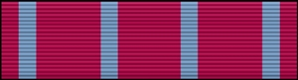

Auxiliary Plaque of Merit
DATE: ___________
ORIGINATOR: ______________________________________
MEMBER’S NAME: ______________________________________
- Extreme skill in performing an assist or rescue at risk to the Auxiliarist’s life.

  - Can only be given for an assist or rescue (operational).

  - Heroism in the face of grave personal risk that clearly stands out as above normal expectations.

- Must be approved by a CG Flag Officer.

- Summary of Action or service must accompany Award Form and citation.

- Submit this form along with completed and signed CG 1650 form and award citation.

- Are all: spelling, grammar, punctuation, line count, type and point, and margins correct?

- Does the award citation meet the criteria required?

Routing Signatures:
Flotilla Commander ______________________ Recommended: _____ Not Recommended: ______
Division Commander ______________________ Recommended: _____ Not Recommended: ______
PDCA-AC ______________________ Recommended: _____ Not Recommended: ______
District Commodore ______________________ Recommended: _____ Not Recommended: ______
DIRAUX ______________________ Approved: _____ Not Approved: ______
District Commander: ____________________ Approved: _____ Not Approved: ______

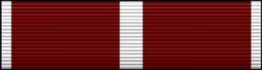

Auxiliary Legion of Merit
DATE: ___________
ORIGINATOR: ______________________________________
MEMBER’S NAME: ______________________________________
- Equivalent to the US Coast Guard Legion of Merit.

  - Awarded for service comparable to the ADSM but in a duty of lesser, though considerable, responsibility.

- Measurable, positive effect on the Auxiliary across multiple districts or at the Auxiliary Area or national level (national or multi-regional scope).

- Must be approved by a CG Flag Officer.

- Summary of Action or service must accompany Award Form and citation.

- Submit this form along with completed and signed CG 1650 form and award citation.

- Are all: spelling, grammar, punctuation, line count, type and point, and margins correct?

- Does the award citation meet the criteria required?

Routing Signatures:
Flotilla Commander ______________________ Recommended: _____ Not Recommended: ______
Division Commander ______________________ Recommended: _____ Not Recommended: ______
PDCA-AC ______________________ Recommended: _____ Not Recommended: ______
District Commodore ______________________ Recommended: _____ Not Recommended: ______
DIRAUX ______________________ Approved: _____ Not Approved: ______
District Commander: ______________________ Approved: _____ Not Approved: ______
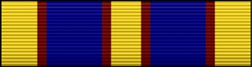

Auxiliary Distinguished Service Medal
DATE: ___________
ORIGINATOR: ______________________________________
MEMBER’S NAME: ______________________________________
- Equivalent to US Coast Guard Distinguished Service Medal.
  - Traditionally, it’s presented to NACO upon completion of their tour.
  - Recognizes exceptionally meritorious service and distinguished service to the US Coast Guard Auxiliary as a national organization.
- Recognizes exceptional performance of duty that benefited the Auxiliary as a whole.
- Performance clearly of a much higher level than normally expected and must have a measurable, positive effect on the entire organization.
- Wording in commendation should include member DISTINGUISHED him/herself and contributed EXCEPTIONALLY MERITORIOUS service WORTHY OF SPECIAL RECOGNITION that contributed significantly to the ENTIRE AUXILIARY ORGANIZATION.
- Must be awarded/approved by the Commandant.
- Summary of Action or service must accompany Award Form and citation.
- Submit this form along with completed and signed CG-1650 form and award citation.
- Are all: spelling, grammar, punctuation, line count, type and point, and margins correct?
- Does the award citation meet the criteria required?

Routing Signatures:
Flotilla Commander ______________________ Recommended: _____ Not Recommended: ______
Division Commander ______________________ Recommended: _____ Not Recommended: ______
PDCA-AC ______________________ Recommended: _____ Not Recommended: ______
District Commodore ______________________ Recommended: _____ Not Recommended: ______
DIRAUX ______________________ Approved: _____ Not Approved: ______
District Commander: ____________________ Approved: _____ Not Approved: ______
The Commandant: ____________________ Approved: _____ Not Approved: ______

AWARDS PROCESS FLOW CHARTS

ACLOC & MTC AWARDS: 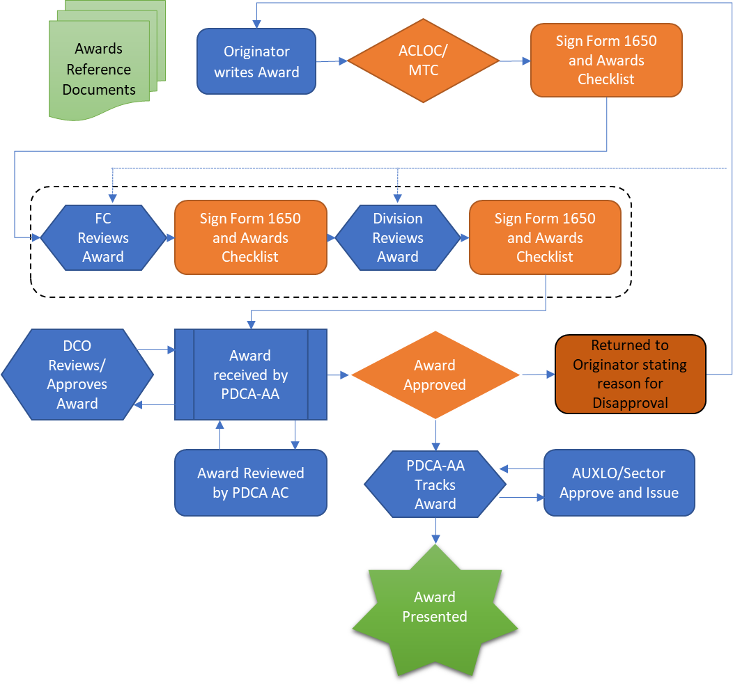

HIGHER LEVEL FORMAL AWARDS:
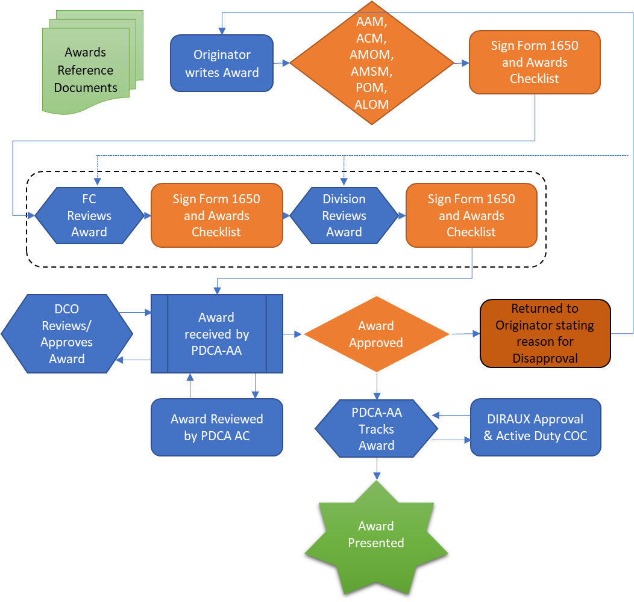

DISTRICT STAFF AWARDS

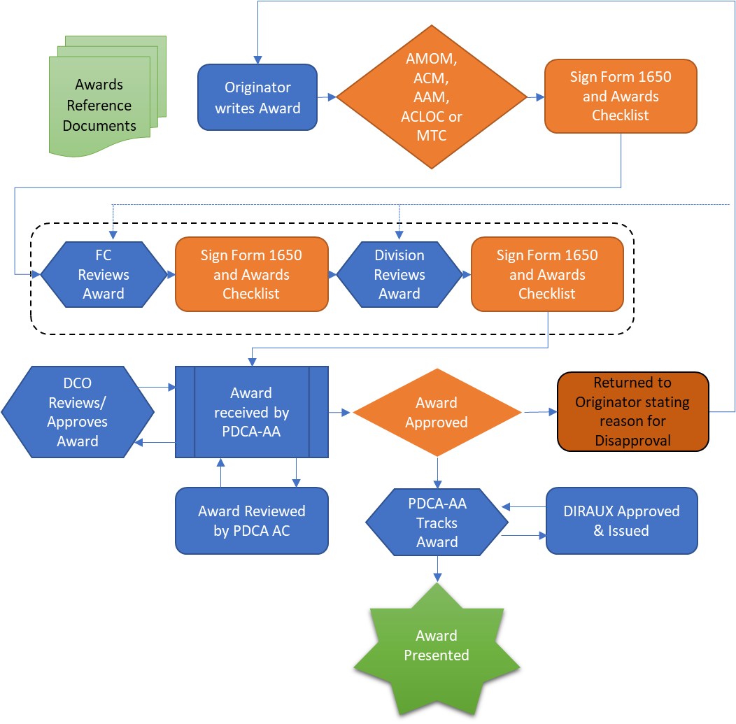

DCO Approves/Disapproves Award:

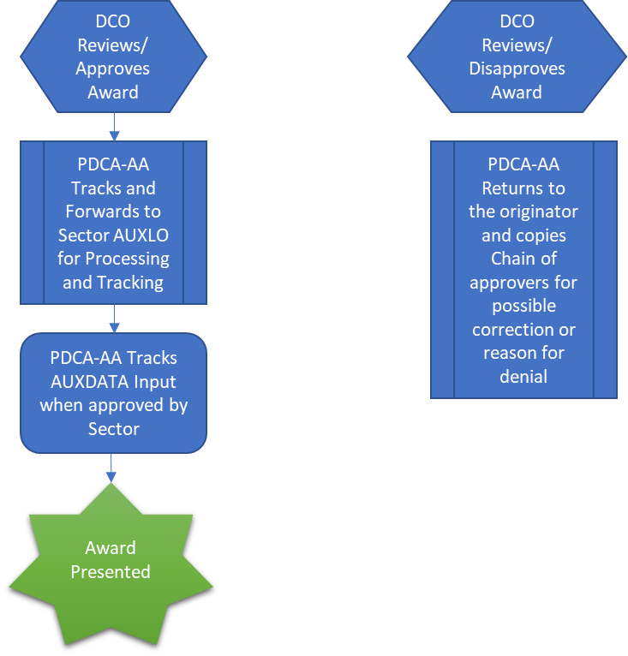

Awards by Due Dates

Jan 15 District 11S Auxiliarist of the Year (AUXOY):
The award recognizes exemplary performance by an eligible Auxiliarist during the previous 12 months. Only Auxiliarists who have demonstrated sustained, exceptional standards of proficiency and conduct, and whose appearance and bearing were consistently impeccable shall be considered for this award.

Apr 1 NACO 3 Star Award for Diversity Excellence:
This award is for the prior calendar year. Flotilla Commanders may complete diversity application by verifying that all required goals have been completed, including:
Goal 1- Create a positive environment
Goal 2- Value all members
Goal 3- Promote individual success
Goal 4- Carry out diverse outreach activities in the community
You may apply annually for this award. Link: http://wow.uscgaux.info/content.php?unit=D-DEPT&category=diversity-excellence-award

Apr 1 NACO Membership Growth Award – Individual:
This award is for the prior calendar year. To earn “NACO Membership Growth Award-Individual”, the individual must have recruited five new members in “Award Year”, and be considered a “sponsor” of such members. Each member must have been assigned a Member ID number by DIRAUX. Link: http://hdept.cgaux.org/pdf/nmga_if.pdf

Apr 1 NACO Membership Growth Award – Flotilla:
This award is for the prior calendar year. To earn “NACO Membership Growth Award-Flotilla,” the Flotilla must have recruited enough new members to net 2 additional members during “Award Year” based on a comparison of “Current Calendar Year” and Award Year (prior calendar year) total membership. Link: http://hdept.cgaux.org/pdf/nmga_fdf.pdf

Apr 1 NACO Membership Growth Award – Division:
This award is for the prior calendar year. To earn “NACO Membership Growth Award-Division,” the Division must have recruited enough new members to net 2 additional members multiplied by the number of Flotillas in the Division from “Award Year” based on a comparison of “Current Calendar Year” and Award year (prior calendar year) total membership. Link: http://hdept.cgaux.org/pdf/nmga_fdf.pdf

Apr 1 NACO Membership Growth Award – District:
This award is for the prior calendar year. To earn “NACO Membership Growth Award-District,” a District must have increased the overall membership in that District by a minimum of as reflected in AUXDATA, during the award year. The top 3 Auxiliary Districts with the greatest percentage increase in new members in “Award Year” (prior calendar year) are eligible.

Apr 1 NACO 3 Star Award for Excellence in Auxiliary Core Training (AUXCT)
This award is for Flotilla’s achievement percentage unless they are already AUXCT compliant. The Flotilla Commander must confirm award eligibility by obtaining the following information from their “IS” officer:
The AUXDATA member roster for their flotilla contains the Base Enrollment Date (BED), listed in AUXDATA as “Base Start Date”, for each member. By counting all the included members whose BED is 31 December of the award year or prior to that date, the Flotilla Commander can determine who should be part of the calculation.
The AUXDATA Training Record Report or the AUXINFO Tasks Cube can be used to find members who have completed all the AUXCT courses and have maintained currency. Link: http://tdept.cgaux.org/mt/AUXMT_NACO_3-Star_Award_2016-01-11.pdf

May 1 Commodore Donald L. Frasch Inspirational Leadership Award:
This award recognizes the most exemplary performance by a Flotilla Commander during the previous calendar year. Only Flotilla Commanders who have demonstrated sustained, exceptional standards of proficiency and conduct, and whose appearance and bearing were consistently impeccable, shall be considered. Nominees must meet the criteria found in AUXMAN Chapter. 11.A.16.f.(1). Nomination packages shall adhere to the minimum requirements for such an award as prescribed in the sample formant in Appendix F of the Auxiliary Manual.

Jun 1 District 11S Publications Award:
Awarded to the Flotilla and Division Publication Officers whose publications are judged to be the best in the District. To qualify for consideration, publications must be issued with sufficient frequency (four per Division and six per Flotilla annually) and be in compliance with the most recent Commandant Publications Guide (COMDTPUB P5600.7 (SERIES)). Eligible Publications Officers will submit their newsletters directly to the District Staff Officer-Publications. Link: Find our Link

Aug 1 Auxiliary Diversity Award:
The Auxiliary Diversity Award recognizes the most exemplary performance in the field of diversity by an eligible Auxiliarist. Only those Auxiliarists who have demonstrated sustained, exceptional standards of conduct and consistent support of the Auxiliary’s diversity goals and the Coast Guard Diversity Policy Statement shall be considered for nomination. This award is not an annual award, but rather shall be implemented in accordance with the following provisions at the discretion of the NACO.
Nominees for this award must meet the following criteria:
a- Be an Auxiliarist in good standing for at least one year at the time of nomination.
b- Demonstrated exemplary conduct.
c- Exemplified Coast Guard core values of “Honor, Respect, and Devotion to Duty.”
d- Delivered consistently outstanding performance in terms of leadership in the field of diversity, personal conduct, and work ethics, and support of the Coast Guard’s Diversity Policy.
e- Displayed superb initiative and motivation that helped significantly
advance the Coast Guard’s diversity goals: create a positive environment, value all members, and promote individual success.
f- Participated in recruiting and retention activities to increase the diversity of the Auxiliary.
g- Participated in diversity training sessions and presentations.
h- Promoted the NACO’s 3-Star Diversity Awards.
i- Projected professional uniform appearance and bearing.
j- Other related contributions, achievements, and awards during the period should be included for consideration
For further information, please check the Auxiliary Manual Chapter 11, Section A.16.g.

Oct 1 Charles S. Greanoff Award Inspirational Leadership Award
Nominees for this award must meet the following criteria:
a- Be an Auxiliarist in good standing at the time of selection
b- Served as incumbent FC at the time of the solicitation for the award
c- Regularly demonstrated unwavering leadership prowess, including the ability to gain genuine commitment from all levels of the organization
d- Exemplified Coast Guard core values of “Honor, Respect and Devotion to Duty”
For further information, please check the Auxiliary Manual Appendix F-5

Nov 1 AFRAS Silver Award (Association for Rescue at Sea)
Based on the current calendar year. This award is presented annually to a deserving Auxiliarist for an act involving lifesaving from inland or coastal waters where heroic action of an Auxiliarist was uniquely distinguished. Link: http://hdept.cgaux.org/pdf/National%20Awards%20Guide.pdf

DEC 1 Auxiliarist of the Year (AUXOY) National
Based on the current calendar year.
a- Be a member in good standing of the Auxiliary for no less than one year from initial enrollment to the date of nomination.
b- Demonstrated exemplary conduct.
c- Embraced Coast Guard core values of “Honor, Respect and Devotion to Duty”.
d- Projected exceptional uniform appearance and bearing
e- Delivered consistently outstanding performance in terms of leadership, Auxiliary program skills, personal and work ethics and Auxiliary knowledge.
f- Displayed superb initiative and motivation that helped significantly advance themselves and Auxiliary program(s).
g- Performed duties in outstanding fashion and achieved results of high quality, customer service and teamwork that resulted in improved efficiency and effectiveness of Auxiliary and/or Coast Guard unit(s).
For further information, please check the Auxiliary Manual appendix F-3

AUTOMATICALLY GENERATED AWARDS

Marine Retailers Association Award (MRAA)
This award is automatically calculated without requiring any computations by Flotilla, Division or District Staff. Highest total points for all criteria serve as the determining factor for selection of the winning Flotilla. Criteria compares number of vessel safety checks, number of AUXOP, Basically Qualified and Initially Qualified members, number of Vessel Examiners, number of Program Visitors, number of Vessel Examiners performing over 35 Vessel Safety Checks, and the number of Program Visitors doing over 20 Program Visits. Data is calculated from 1 Jan through 31 Dec. of the “Award Year.”
Link: http://www.cgaux.org/nac/awards.php

Boat US Best Flotilla Award
The Flotilla with the highest points based upon increase in membership, number of operational missions, number of vessel safety checks, number of public education sessions, number of member training sessions, and number of public affairs missions is selected for the Boat US Best Flotilla Award.
Link: http://www.cgaux.org/nac/awards.php

Coast Guard RBS Award of Excellence (Eagle Award)
This award is based on AUXDATA (total of “Award Year” and “Current Year” credits) for 1 Auxiliarist from each region (Atlantic, Central and Pacific).
Recognizes Auxiliarists who made outstanding contributions to, and who best exemplified “Excellence in Recreational Boating Safety Missions.”
For further information, please check the Chapter 8 of the Auxiliary Manual
National Boating Federation (NBF)
This award is automatically calculated without requiring any computations by Flotilla, Division or District Staff. Highest total points for all listed criteria serve as the determining factor for selection of the winning Flotilla. Criteria consists of: Membership at beginning of award year, number of instructors at end of award year, total number of multi-lesson courses taught, total public education class sessions, number of BS&S lessons, number of S&S lessons, number of ACN/BCN lessons taught, number of Boats “N” Kids lessons taught, number of Boating Safely lessons, number of ABS lessons, number of State Safe Boating lessons.
Link: http://www.cgaux.org/nac/awards.php

AUTOMATICALLY GENERATED AWARDS BY DISTRICT 11S

District Commodore’s Certificate of Excellence for:
- Recreational Boating Safety- Auxiliarist must have contributed or exceeded 250 hours in any one-mission area or a combination of mission areas.
- Operations/Marine Safety- Auxiliarist must have contributed or exceeded 200 hours in any one-mission area or a combination of mission areas
- Member Services- Auxiliarist must have contributed or exceeded 100 hours in any one-mission area or a combination of mission areas.
- Multi-Department- Auxiliarist must have contributed or exceeded 250 hours in any one-mission area or a combination of mission areas.
- Operational Standby- Auxiliarist must have contributed or exceeded 100 hours in any one-mission area or a combination of mission areas.
- Radio Watch Standing, Coast Guard Operational & Administrative Support- Auxiliarist must have contributed or exceeded 100 hours in any one-mission area or a combination of mission areas.
- Aviation- Auxiliarist must have contributed or exceeded 100 hours in any one-mission area or a combination of mission areas.
- Commodore William Mansfield Perpetual Trophy- This award honors the memory of Commodore William Mansfield who served as District Commodore from 1948 to 1950. First awarded in 1950, the Mansfield Perpetual Trophy is presented annually to the Flotilla that conducted the highest number of Vessel Safety Checks in the previous year.
- Commodore’s Cup Awards – The Commodore’s Cup Awards are presented annually to the best performing Flotilla and Division in District 11S. Data used to select the winning Flotilla and Division is taken from AUXDATA and AUXINFO, and each unit’s performance in the district’s core activities (as determined by the EXCOM) is measured against its performance in those same activities for the prior year. In recognition of receiving the Commodore’s Cup for Best Performance by a Division, each member of the Division’s leadership team may be awarded the Coast Guard Meritorious Team Commendation.
  - The Flotilla that is awarded the Commodore’s Cup for Best Flotilla of the Year for its performance in the District’s core activities shall be recommended for the Flotilla Meritorious Achievement Medal (FMAM). Only one Flotilla in the District may receive the FMAN each year and eligible members of the Flotilla awarded the FMAM may wear the ribbon that accompanies the award.

Information on all National awards is contained in the National Awards Guide, along with directions for submitting the awards.
NATIONAL AWARDS GUIDE LINK:
http://hdept.cgaux.org/pdf/National%20Awards%20Guide.pdf

PRESIDENTS VOLUNTEER SERVICE AWARD
This is a program for volunteers (Auxiliary members qualify). There are several different award levels. Certificates and/or ribbons/plaques must be purchased. Below is the link which explains this program.
https://www.presidentialserviceawards.gov/the-award

AWARDS TEMPLATES

THE COMMANDANT OF THE COAST GUARD TAKES PLEASURE IN PRESENTING THE
COAST GUARD MERITORIOUS TEAM COMMENDATION to:
UNITED STATES COAST GUARD AUXILIARY
(NAME OF TEAM – ALL CAPITAL LETTERS)

for service as set forth in the following
CITATION:
"For exceptionally meritorious service from Month Year to Month Year while serving on the Name of Team.
There must be no more than 24 lines total in length without the Operational Distinguishing Device or no more than 26 lines with the Operational Distinguishing Device authorization. The entire award must fit on one page, within the margins (1.9" on top and 1.0" on the sides and bottom)
The dedication, pride, and professionalism displayed by the Name of Team are in in keeping with the highest traditions of the United States Coast Guard and the United States Coast Guard Auxiliary."

[If appropriate] The Operational Distinguishing Device is authorized.
For the Commandant,
FI. MI. LASTNAME OF SECTOR COMMANDER (ALLCAPS)
Captain, U.S. Coast Guard
Commander / Commanding Officer, Sector / Air Station

Figure 1: Citation - Meritorious Team Commendation

From: Commandant

To: Commodore/Mr./Ms. First Name MI. Last Name, U.S. Coast Guard Auxiliary

Subj: AUXILIARY COMMANDANT’S LETTER OF COMMENDATION

1. I note with pride and am pleased to commend you for your performance of duty as Auxiliary Position from Month Year to Month Year.
There must be no more than 24 lines total in length without the Operational Distinguishing Device or no more than 26 lines with the Operational Distinguishing Device authorization. The entire award must fit on one page, within the margins (1.9" on top and 1.0" on the sides and bottom)

2. You are commended for your outstanding performance of duty. By your meritorious service, you have upheld the highest traditions of the United States Coast Guard and the United States Coast Guard Auxiliary.

3. You are hereby authorized to wear the Auxiliary Commandant’s Letter of Commendation Ribbon Bar (gold/silver star in lieu of a second/sixth. [if appropriate] The Operational Distinguishing Device is authorized.

For the Commandant,

Name of Sector Commander or Director of Auxiliary
Captain, U.S. Coast Guard
Commander, Sector Name or Director of Auxiliary

Figure 2: Citation - Auxiliary Commandant Letter of Commendation

CITATION TO ACCOMPANY THE AWARD OF
THE AUXILIARY ACHIEVEMENT MEDAL
[If appropriate] (GOLD/SILVER STAR IN LIEU OF A SECOND/SIXTH)
TO COMMODORE/ MR./ MS. FIRSTNAME MI. LASTNAME
UNITED STATES COAST GUARD AUXILIARY

Commodore / Mr. / Ms. LAST-NAME-CAPITALIZED is cited for superior performance of duty while serving as Position from Month Year to Month Year.
Total body not to exceed 12 lines without the Operational Distinguishing Device authorization or 14 lines with the Operational Distinguishing Device authorization.
Commodore/Mr./ Ms./ LASTNAME’s diligence, perseverance, and devotion to duty are most heartily commended and are in keeping with the highest traditions of the United States Coast Guard and the United States Coast Guard Auxiliary.
[If appropriate] Operational Distinguishing Device is authorized.

Figure 3: Citation - The Auxiliary Achievement Medal
CITATION TO ACCOMPANY THE AWARD OF
THE AUXILIARY COMMENDATION MEDAL

[If appropriate] (GOLD/SILVER STAR IN LIEU OF A SECOND/SIXTH)
TO
COMMODORE/ MR./ MS. FIRSTNAME MI. LASTNAME
THE UNITED STATES COAST GUARD AUXILIARY
Commodore /Mr./ Ms./ LASTNAME is cited for outstanding achievement while serving as Position from Month Year to Month Year. During this period,
Total body not to exceed 12 lines without the Operational Distinguishing Device authorization or 14 lines with the Operational Distinguishing Device authorization.
Commodore/ Mr./ Ms./ LASTNAME’s dedication, judgment, and devotion to duty are most heartily commended and are in keeping with the highest traditions of the United States Coast Guard and the United States Coast Guard Auxiliary.
[If appropriate] Operational Distinguishing Device is authorized.

Figure 4: Citation - The Auxiliary Commendation Medal
CITATION TO ACCOMPANY THE AWARD OF
THE AUXILIARY MEDAL OF OPERATIONAL MERIT

[If appropriate] (GOLD/SILVER STAR IN LIEU OF A SECOND/SIXTH)
TO
COMMODORE/ MR./ MS. FIRSTNAME MI. LASTNAME
UNITED STATES COAST GUARD AUXILIARY
Commodore/ Mr./ Ms./ LASTNAME) is cited for meritorious service in the performance of duty as Position from Day Month Year to Day Month Year.
Total body not to exceed 12 lines without the Operational Distinguishing Device authorization or 14 lines with the Operational Distinguishing Device authorization.
Commodore/Mr./ Ms./ LASTNAME’s judgment and devotion to duty are most heartily commended and are in keeping with the highest traditions of the United States Coast Guard and the United States Coast Guard Auxiliary.
[If appropriate] Operational Distinguishing Device is authorized.

Figure 5: Citation - The Auxiliary Medal of Operational Merit
CITATION TO ACCOMPANY THE AWARD OF
THE AUXILIARY MERITORIOUS SERVICE MEDAL
[If appropriate] (GOLD/SILVER STAR IN LIEU OF A SECOND/SIXTH)
TO
COMMODORE/ MR./ MS. FIRSTNAME MI. LASTNAME
UNITED STATES COAST GUARD AUXILIARY
Commodore/ Mr./ Ms. LASTNAME) is cited for meritorious service in the performance of duty as Position from Month Year to Month Year.
Total body not to exceed 12 lines without the Operational Distinguishing Device authorization or 14 lines with the Operational Distinguishing Device authorization.
Commodore/ Mr./ Ms./ LASTNAME’s dedication and devotion to duty are most heartily commended and are in keeping with the highest traditions of the United States Coast Guard and the United States Coast Guard Auxiliary.
[If appropriate] Operational Distinguishing Device is authorized.

Figure 6: Citation - The Auxiliary Meritorious Service Medal
CITATION TO ACCOMPANY THE AWARD OF
THE AUXILIARY PLAQUE OF MERIT
If appropriate second or third award etc. insert: GOLD STAR IN LIEU OF A SECOND or THIRD)
TO
MR./MS./COMMODORE - FULL NAME
THE UNITED STATES COAST GUARD AUXILIARY
(COMMODORE/MR./ MS./ LAST NAME CAPITALIZED is cited for extreme skill in effecting a rescue on (date)
at risk to his/her own life.
B
O
D
Y

BODY CANNOT EXCEED 16 LINES

Mr./Ms./COMO Last Name rapid response, skillful direction, and unselfish actions are most heartily commended and are in keeping with the highest traditions of the United States Coast Guard and the United States Coast Guard Auxiliary.

Figure 7: Citation - The Auxiliary Plaque of Merit
CITATION TO ACCOMPANY THE AWARD OF
THE COAST GUARD AUXILIARY LEGION OF MERIT
TO
COMMODORE/ MR./ MS FIRST NAME, MIDDLE INITIAL, LAST NAME
UNITED STATES COAST GUARD AUXILIARY

(COMMODORE/MR./ MS./ LAST NAME CAPITALIZED)) is cited for outstanding meritorious service as (state position) from (month, year) to (month, year). (Commodore/Mr./ Ms./ LAST NAME CAPITALIZED) provided
B
O
D
Y

BODY CANNOT EXCEED 16 LINES

(Commodore/Mr./ Ms./ LAST NAME CAPITALIZED) ability, diligence, and devotion to duty are most heartily commended and are in keeping with the highest traditions of the United States Coast Guard and the United States Coast Guard Auxiliary.

Figure 8: Citation - The Coast Guard Auxiliary Legion of Merit
CITATION TO ACCOMPANY THE AWARD OF
THE AUXILIARY DISTINGUISHED SERVICE MEDAL
TO
COMMODORE/ MR./ MS FIRST NAME, MIDDLE INITIAL, LAST NAME
UNITED STATES COAST GUARD AUXILIARY
(COMMODORE/MR./ MS./ LAST NAME CAPITALIZED) is cited for exceptionally meritorious service to the Government of the United States in a position of great responsibility as (state position) from (month, year) to (month, year). Exercising exceptional vision and exemplary leadership, (Commodore/Mr./ Ms./ LAST NAME CAPITALIZED)
B
O
D
Y

BODY CANNOT EXCEED 16 LINES

(Commodore/Mr./ Ms./ LAST NAME CAPITALIZED) leadership, dedication, and devotion to duty are most heartily commended and are in keeping with the highest traditions of the United States Coast Guard and the United States Coast Guard Auxiliary.

Figure 9: Citation - The Auxiliary Distinguished Service Medal
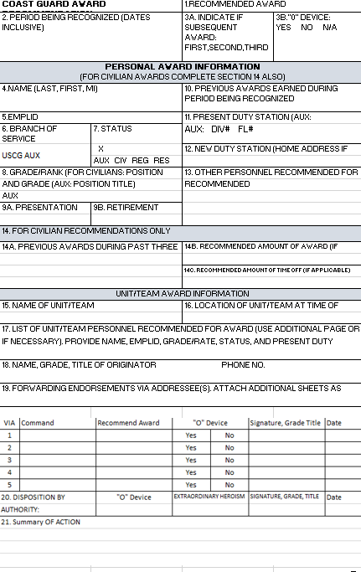

Figure 10: USCG Auxiliary D11S Revised 1650

Description of USCG Auxiliary Awards:
Award Image | Name | Description | Eligibility
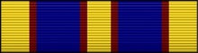 | Auxiliary Distinguished Service Award | The Auxiliary Distinguished Service Medal (DSM) recognizes Auxiliarists who distinguish themselves by contributing exceptionally meritorious and distinguished service to the Coast Guard Auxiliary. The Coast Guard Auxiliary Distinguished Service Award is only awarded by the Commandant. | The performance required to justify this award is exceptional performance of duty, which benefits the Auxiliary as a whole. This performance, therefore, must be clearly much higher than normally expected, and must have a measurable, positive effect on the entire organization. Normally this award will be given to elected and appointed officers for extraordinary achievement. This statement should not be interpreted to preclude the award to any Auxiliarist whose service meets the requirement.  The key words for this award are distinguished, operational, and exceptional meritorious service. To justify this award, exceptional performance of duty, clearly much higher than normally expected, which has resulted in significant benefit to the entire Auxiliary organization, is required.

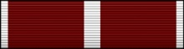 | Legion of Merit | The Auxiliary Legion of Merit (ALOM) is awarded for service comparable to the ADSM but in a duty of lesser, though considerable, responsibility. The Commandant or any Coast Guard Vice Admiral may award the ALOM. All ALOM packages must be submitted through the appropriate Auxiliary chain of leadership to NACO for review and approval. This applies prior to District review and subsequent routing of nominations to Area or Headquarters level. | In general, the ALOM will be awarded to Auxiliarists in leadership positions who have performed such exceptionally meritorious service as to justify the award of the ADSM, except as to degree of merit. Recognized performance must clearly be much higher than expected and have a measurable, positive effect on the Auxiliary across multiple Auxiliary regions or at Auxiliary Area or National level. This should not be interpreted to preclude the award of the ALOM to any Auxiliarist whose acts or services meet the requirements. When the degree of achievement or service rendered, although meritorious, is not sufficient to warrant award of the ALOM, the AMSM should be considered.
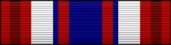 | Guardian Medal | This medal is awarded to senior Government transportation officials, who through visionary leadership, have re-directed the focus and resources of their organization, or major entities within their organization, and have a profound impact in their field, Federal Government, or on the general public in providing for the protection and security of the U.S. and its citizens. | To justify this decoration, nominations must demonstrate exceptional performance of duty while in a position of great responsibility, clearly above that normally expected, which has contributed materially to the betterment of the U.S.

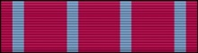 | Auxiliary Plaque of Merit | The Auxiliary Plaque of Merit is given to Auxiliarists in recognition of extreme skill in performing an assist or rescue that involves risk to the Auxiliarist’s life. The Auxiliary Plaque of Merit may be awarded by any Flag officer with Chief Director of Auxiliary concurrence. | This award recognizes heroism in the face of grave personal risk and which clearly stands out as above normal expectations. The key aspects of performance for award of the Auxiliary Plaque of Merit are extreme skill, assist or rescue, and risk to the Auxiliarist’s life. As can be seen, the Auxiliary Plaque of Merit can only be given for an assist, or rescue. The Auxiliarist must have exercised extreme skill, as opposed to just skill required for the Medal of Operational Merit. Lastly, there must have been risk to the Auxiliarist’s life. Neither the assist nor rescue need be successful, only that the action required extreme skill and was performed or attempted at risk to the Auxiliarist’s life.
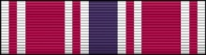 | Auxiliary Meritorious Service Award | The Auxiliary Meritorious Service Medal (MSM) is awarded to Auxiliarists who have contributed exceptional meritorious service to the Coast Guard and/or Auxiliary. Auxiliarists who serve in any capacity within the Auxiliary are eligible. The Auxiliary MSM may be awarded by any Flag officer. The meritorious performance of duty must have enhanced Auxiliary goals. | This performance must clearly be of a nature much higher than that normally expected, and which has a significant positive effect on the ability of the Coast Guard and/or the Auxiliary to complete its missions and goals. For this award, the key words are outstanding and meritorious service worthy of special recognition, which contributes significantly to fulfillment of Auxiliary goals at the local level.

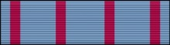 | Medal of Operational Merit | The Medal of Operational Merit is given to Auxiliarists in recognition of outstanding skill in performing an assist, rescue, or other meritorious operational service. The Medal of Operational Merit may be awarded by any Coast Guard Commanding officer (06 and above) of an operational unit or serving as DVC or higher at a district office, MLC, HQ, or serving as a Director. |  | This award recognizes outstanding achievement or service of an operational nature (defined as direct, hands on, underway, surface or airborne aviation mission activity) worthy of special recognition. For this award, the key words are outstanding operational performance, skill, assist, rescue or other meritorious operational service. To receive the Medal of Operational Merit, only skill is required, not extreme skill, and therefore does not have to be a risk to the Auxiliarist’s life. Outstanding operational performance and other meritorious operational service have been included in this category. This was added to allow recognition of a cumulative series of operational services, none of which, standing alone, would merit this award, but taken as a group, do merit this level of recognition.
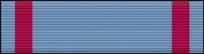 | Auxiliary Commendation Medal |  | The Auxiliary Commendation Medal (ACM) is given to Auxiliarists in recognition of outstanding assistance that furthers any of the Auxiliary’s authorized activities, except operations (since the Medal of Operational Merit is for operations). The Auxiliary Commendation Medal may be awarded by any Coast Guard Commanding officer (06 or above) of an operational unit or serving as DVC or higher at a district office, MLC, HQ, or serving as a Director. |  | This award recognizes outstanding achievement or service worthy of special recognition as described below. The key words for the Auxiliary Commendation Medal are outstanding achievement, which significantly furthers any of the Auxiliary’s authorized activities. The Auxiliary Commendation Medal is for outstanding administrative services. This requires services accomplished in a manner, which is much better than could normally be expected from an Auxiliarist of like capability and experience. Neither doing a difficult job well nor doing a routine job in an excellent manner will suffice. The achievement must be truly outstanding.

 | Auxiliary Achievement Medal | The Auxiliary Achievement Medal (AAM) is given to Auxiliarists in recognition of their sustained professional and/or leadership achievements in administration or operations. The Auxiliary Achievement Medal may be awarded by any Coast Guard Commanding officer (0-4 and above) of an operational unit or serving as a DVC or higher at a district office, MLC, HQ or Director. | This award recognizes outstanding achievement or service of a nature, which is worthy of special recognition as described below. The key words for the Auxiliary Achievement Medal are sustained professional, leadership achievements and period of time. The Auxiliary Achievement is for recognition of Auxiliarists who have maintained an outstanding level of performance and/or achievement over a period of time to further authorized activities of the Auxiliary. The achievements could be in administration or operations.

 | Auxiliary Commandant Letter of Commendation |  | The Auxiliary Letter of Commendation Ribbon (ACLOC) is the Auxiliary’s equivalent to the Coast Guard’s Commandant Letter of Commendation (CLOC) Ribbon. Coast Guard units and Directors can prepare award citations using the same criteria, format, and style as the CLOC. |  | The award is intended for Auxiliarists serving in any capacity with the Coast Guard or Auxiliary for an act of service resulting in unusual and/or outstanding achievement, whose performance is lesser than that required for the Auxiliary Achievement Medal. The award can also be used to recognize an Auxiliarist’s service/performance for a special event or project. Commanding officers/Group Commanders, Directors, DVCs of HQ, MLC, ISC or district offices, O-4 and above, can approve the ACLOC. Recommendations are made on the CG-1650 award recommendation form and submitted to the approving official, via the Auxiliarist’s chain of leadership and management.
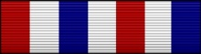 |  | Transportation 9/11 Ribbon |  | This ribbon is awarded to an individual serving in any capacity with the DOT, merchant marines, or other civilians, for an act or service that contributed to recovery from the attacks of 11 September 2001, and force protection following the attacks or efforts that directly contributed to the increased infrastructure security effort between 11 September 2001 and 11 September 2002. |  | Specifically, it may be awarded to the following authorized personnel:  Coast Guard units that shifted Operational Control (OPCON) to Operations Enduring Freedom, Noble Eagle, or Protecting Liberty for any amount of time between 11 September 2001 and 11 September 2002.  All personnel involved in patrolling harbors, critical infrastructure facilities, escorting high interest vessels, and conducting boardings of vessels entering U.S. waters during the period of 11 September 2001 to 11 September 2002. Participation in these operations must be no less than 14 days.  All personnel to include active, Reserve, Auxiliary, and civilian personnel that manned or augmented for no less than 14 days, Coast Guard, DOT, FEMA, and DoD command centers (including Operations Centers at Groups and above, COTP ICS, FEMA Regional Operations Centers, and VTS) between 11 September 2001 and 11 September 2002.

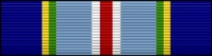 | Coast Guard Special Operations Ribbon | Auxiliarists who participate in a Coast Guard special operation, not involving combat, may receive this award. It is for Auxiliarists not recognized by another service award for the same operation, during the same period of service. This award can be authorized by the Commandant or an Area Commander.
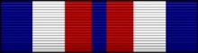 | Auxiliary Recruiting Service Award | The Auxiliary Recruiting Service award is awarded for recruiting seven or more new Auxiliarists into the Auxiliary as determined and credited through the FC.
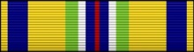 | Coast Guard Recruiting Service Ribbon | Auxiliarists who complete the Coast Guard recruiter PQS and have augmented a recruiting office for two years are eligible for the Coast Guard Recruiting Service ribbon. Auxiliarists apply via the Coast Guard recruiter at the recruiting office they augment. Approval authority is the Director, Coast Guard Recruiting Center.
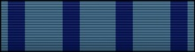 | Specialty Training Ribbon | This recognition is presented to an Auxiliarist who has satisfactorily completed any of the specialty courses. Auxiliarist add 3/16-inch bronze or silver stars to show completion of additional courses. This designation recognizes the satisfactory completion of all six specialty courses, which entitles the Auxiliarist to wear the AUXOP device. After earning the device, Auxiliarist no longer wear the Specialty Ribbon.

 | Marine Safety Trident Training Ribbon | The Marine Safety Training ribbon was created in recognition of the considerable and long-term, sustained effort that Auxiliarists must put forward in order to earn the Auxiliary Marine Safety (Trident) insignia. The ribbon recognizes achievement in the marine safety, security, and environmental protection mission area as a precursor to achievement of the Auxiliary Marine Safety (Trident) insignia. Auxiliarists who successfully complete the following tasks are entitled to wear this ribbon (there is no time limit in which these tasks must be completed):  - Introduction to Marine Safety and Environmental Protection (IMSEP) course.  - If completed prior to 01 Oct 2010, the Auxiliarist must also complete IIMS (Initial Indoctrination to Marine Safety). Note: IIMS was an active duty course which has since been discontinued. If IIMS has not been completed and IMSEP was earned prior to 01 Oct 2010, the new version of IMSEP must be completed.  - Good Mate Course.  - Incident Command System (ICS) courses: ICS100, ICS 200, IS 700, and IS 800.  - ICS 210 (Coast Guard taught) or ICS 300 (FEMA or Coast Guard taught).  - At least one Auxiliary Marine Safety Program PQS.  Successful completion of subsequent program PQS shall be denoted by adding 3/16-inch bronze stars. After earning the Auxiliary Marine Safety insignia, Auxiliarists shall remove this ribbon from wear.

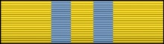 | Operations Program Ribbon | This ribbon recognizes qualifications in the various operations program areas. Auxiliarists who qualify as an Auxiliary crew member, air observer, ATON verifier, Coast Guard Watchstander, Coast Guard boat crewman, or Coast Guard boat engineer may wear the Operations Program Ribbon. Watchstanders and boat engineers are defined as Auxiliarists who have been designated in writing by a Coast Guard unit, or the Director, as qualified in that position. Auxiliarists show multiple qualifications by adding 3/16-inch bronze or silver stars. The “E” device is authorized to be worn on the Auxiliary Operations Program ribbon by Auxiliarists who are currently appointed, or have been appointed, as a QE. No miniature “E” device for miniature medals is authorized.
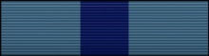 | Examiner Program Ribbon | This ribbon recognizes qualifications in various examiner program areas. Auxiliarists who qualify as a VE, RBSV, or a CFVE may wear the Examiner Program Ribbon. Auxiliarists show multiple qualifications by adding 3/16-inch bronze or silver stars.

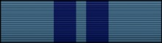 | Instructor Program Ribbon | This ribbon recognizes qualification in the instructor (IT) program.
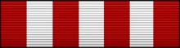 | Auxiliary Public Affairs Ribbon | Awarded to Auxiliarist who achieve the certification of Auxiliary Public Affairs Specialist II.  This level requires an advanced level of expertise. At this level, an individual is expected to not only demonstrate public affairs skills, but assist others in developing and utilizing those skills. This level is that expected of a division or district public affairs officer. Prerequisites are:  - Coast Guard Public Affairs Policy (AUX-21)  - Journalism Advanced (AUX-25)  - ICS 200

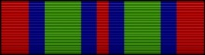 | Auxiliary Public Education Service Award | For instructor and/or instructor aide hours. Complete thirty or more hours of instruction in (PE or MT), or serve as and instructor's aid for sixty or more hours, or complete a combination of instructor hours and instructor aide hours to total at least thirty credits (one instructor hour equals one credit and one aide hour equals 1/2; a credit; for example, 20 hours as instructor equals 20 credits and 20 hours as an aide equals 10 credits, totaling 30 credits and qualifying to receive the award).
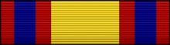 | Auxiliary Operations Service Award |  | Support to CG units and missions, which includes surface operations, air operations and operational Watchstanding (such as communications Watchstander, OOD, manning the SAR desk, etc.) Operations support does NOT include administrative support to operational units, such as answering the office phones, filing case files, and service in the DIRAUX office.  (1) Display the support "S"; device for support activities not involving the movement of a facility; (i.e. Watchstanding). Complete 200 or more hours of operational support activity.  (2) Display the operational "O" device for underway (excluding underway for training), surface mission  activity (60 or more hours); or for airborne aviation mission activity (excluding training) (30 or more hours). Support for on-the-water readiness exercise does qualify as operational service. No combination of surface and air operations is allowable for this award.
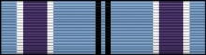 | Coast Guard Auxiliary Humanitarian Service Award |  | The Auxiliary Humanitarian Service Award (HSA) is presented to Auxiliarists who distinguish themselves as individuals or as members of an operational unit by meritorious, direct, non-routine participation in a significant act or operation of a humanitarian nature. Direct participation is defined as being physically present at the designated location, having directly contributed and influenced the action.  This award is considered the Auxiliary equivalent of the military Humanitarian Service Medal (HSM). Since Auxiliarists are not eligible to receive the HSM, the Auxiliary Humanitarian Service Award is awarded to Auxiliarists who participate in the same operations where Coast Guard active duty personnel are awarded the HSM.  Participation in domestic disturbances involving law enforcement, equal rights to citizens or the protection of properties are excluded from this award.
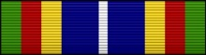 | Coast Guard Bicentennial Unit Commendation |  | Only those Auxiliarists who were members during the entire period from March 1989 to October 1989 are authorized to wear the Coast Guard Bicentennial Unit Commendation. The award consists of a ribbon only. There is no miniature medal.

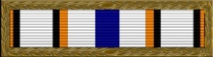 | Secretary's Outstanding Unit Award |  | The Secretary of Transportation Outstanding Unit Award is a unit decoration of the United States Coast Guard which was issued from 1992 to 2003. The decoration is considered the highest unit award of the Coast Guard and is presented to those Coast Guard units which perform outstanding service to the Coast Guard as a whole.
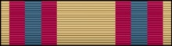 | Auxiliary Sustained Service Award | This award is presented to an Auxiliarist contributing a documented total of 750 volunteer hours of Auxiliary service. Subsequent awards are presented for each additional 750 hours of service until the tenth award is achieved. Auxiliarists indicate multiple awards by adding 3/16-inch bronze or silver stars, until the tenth award, at which time an hourglass device will be used. This award includes a miniature medal, ribbon, and certificate. Eligibility for this award is documented by the Director, using AUXDATA information, whose staff shall then forward the initial medal/ribbon set issue and a prepared certificate to be presented per district/regional policy. Subsequent awards receive the star or hourglass device and a certificate showing the number of hours being recognized.

 | Transportation 9/11 Medal | This medal is awarded to employees of the DOT and private citizens for meritorious service resulting from unusual and outstanding achievement in response to the attacks on 11 September 2001. Specifically, this award is authorized for the following personnel:  Posthumously presented to those who lost their lives during the terrorist attacks of 11 September 2001 that had immediate family employed by DOT.  Employees of DOT who were on scene at the World Trade Center Complex in New York, the crash site in Pennsylvania, or at the Pentagon on 11 September 2001 and performed a role in the initial rescue and recovery operations.  All personnel directly involved in the evacuation of lower Manhattan to include DOT employees, masters and crews of commercial vessels and crews of recreational boats that actually transported evacuees during the evacuation on 11 September 2001. The level of effort must clearly set the Auxiliarist above that described in the 9/11 Ribbon.  Personnel that demonstrated extraordinary participation or leadership while patrolling harbors, securing critical infrastructure facilities, escorting high interest vessels and conducting boardings of vessels entering U.S. waters during the period of 11 September 2001 to 11 September 2002. The level of effort must clearly set the Auxiliarist above that described in the 9/11 Ribbon.  Employees of DOT who demonstrated extraordinary dedication or leadership between 11 September 2001 and 11 September 2002. Participation must have been at an exceptional level to warrant consideration for the awarding of the 9/11 Medal. The level of effort must clearly set the Auxiliarist well above that described in the 9/11 Ribbon.

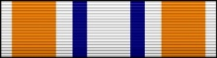 | Coast Guard Presidential Unit Citation | For meritorious achievement and outstanding performance in action from 29 August to 13 September 2005 in preparation for, and response and recovery to the devastation wrought by Hurricane Katrina. The United States Coast Guard anticipated the potential for significant loss of life and property and, in advance of Hurricane Katrina, relocated its personnel, vessels, and aircraft out of “harm’s way.” The Coast Guard successfully executed multiple primary missions throughout the Gulf Coast in the wake of the worst natural disaster in United States history. Responding with more than 4,500 personnel, 130 small boats, 4 cutters, and 60 aircraft to devastation and despair across more than 90,000 square miles and 6,400 miles of coastline, the Coast Guard rescued more than 33,000 people, began clean-up operations of 9.4 million gallons of oil, replaced and repaired over 1,800 aids to navigation, and most importantly provided hope to hundreds of thousands displaced citizens through its proactive and vigorous actions. This inspiring response is a direct result of the spirit and practice of operational initiative, positive leadership and courage of the total Coast Guard force of active duty, reserve, auxiliary and civilian members. Every Coast Guard man and woman demonstrated superior professionalism, commitment, humanitarianism, tenacity, tactical acumen, technical expertise, compassion and support while maintaining the highest level of operational readiness. By their outstanding courage, resourcefulness, and aggressive actions under desperate conditions, the members of the United States Coast Guard reflected great credit upon themselves and upheld the highest traditions of the United States of America.  All Coast Guard members are authorized to wear the Presidential Unit Citation ribbon with a special clasp in the form of the internationally recognized "hurricane symbol.

