Build a Simple Report (AUX Specific Templates)

In the REPORTS Section, Click on ALL FOLDERS

Go to the Folders called FLOTILLA REPORTS (or DIVISION Reports)

Auxiliary specific Report Templates have been provided.

Open the Template that best describes what you want

Click on Filter Icon

Click on the Unit Number filter, change Unit Number and click “Apply”
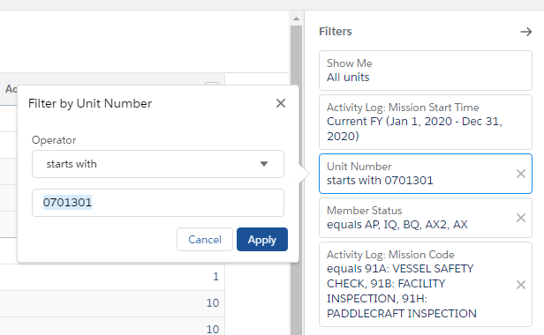

Click down arrow next to edit and select “save as”

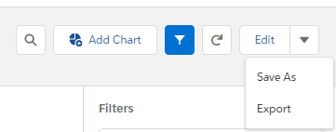

Give the report a name

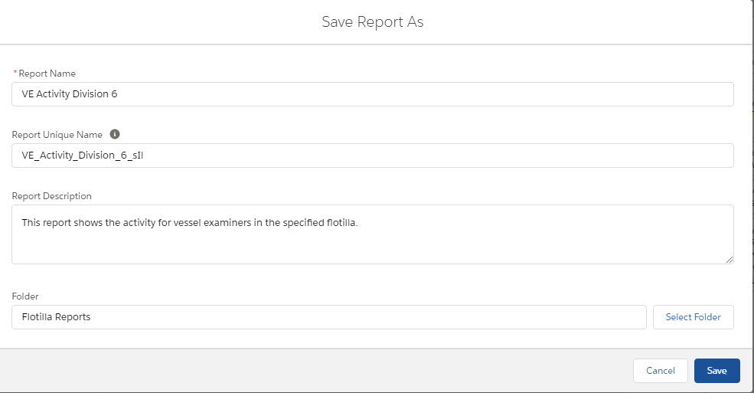

Save to your Private Reports by clicking Select Folder

Click on ALL FOLDERS in box that pops up

Click on PRIVATE Reports and Select Folder
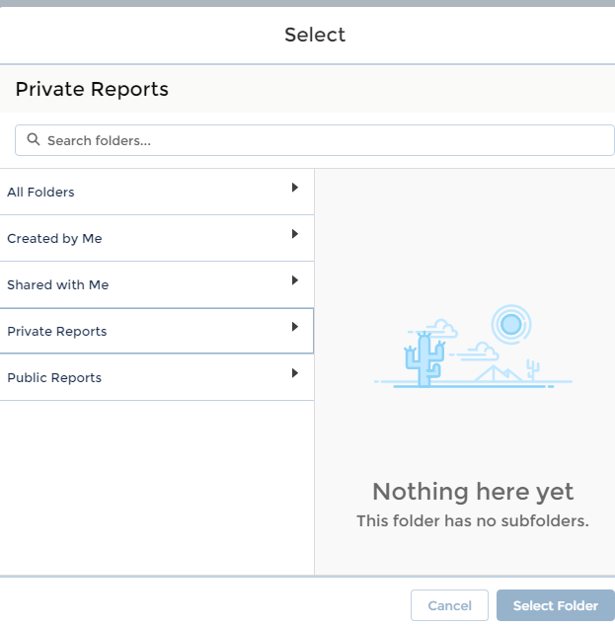

Click SAVE

EXPORT Reports

Click the Down Arrow to the right of EDIT to get to the export function

There are two export formats: Excel or Comma Separated Value (CSV).
Choose Excel for reports that you want to print (CSV is better for creating files that you can upload to Access or another database)

Same Procedure can be used for INDIVIDUAL Reports.

Update the Member Number to show the records for a specific member.
Training Record Report Template
Training Status Report Template

